ENSF 619 Project II

**Group 9**

Aidan Lee 30000074

Andrew Lee 30128102

Justin Leong 10127156

Patrick Linang 10122254

## **Statement of Purpose**

The system is a small and simple application that facilitates requirements-based testing for a software development company. The proposed system tracks current projects but also retains the history of past projects. Projects are created from high-level requirements provided by the customer and managed by project managers. Originators such as users, analysts, or architects, can register low-level requirements for a project. The system also allows developers to submit test scripts to verify that low level requirements have been satisfied. These scripts are run by testers, who record the results. If required, the recorded results may be presented in a court of law as evidence of adequate testing.

## **Flow of Events List**

1. Project manager creates a project with high-level requirements from the customer
2. Originators define lower-level requirements
3. Developer creates test scripts
4. Tester runs test scripts and records results in database

## **Context Diagram**

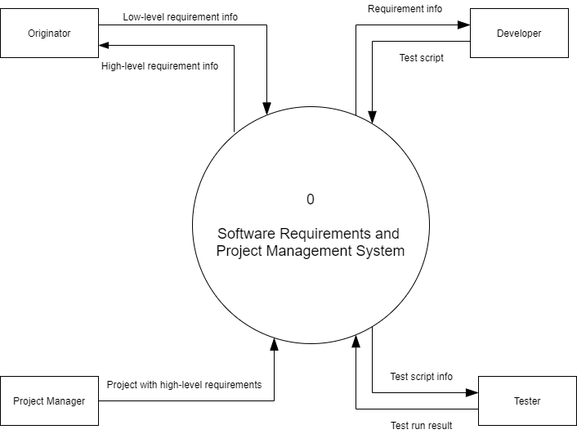

## **Data Flow Diagrams**

### **Level 1**

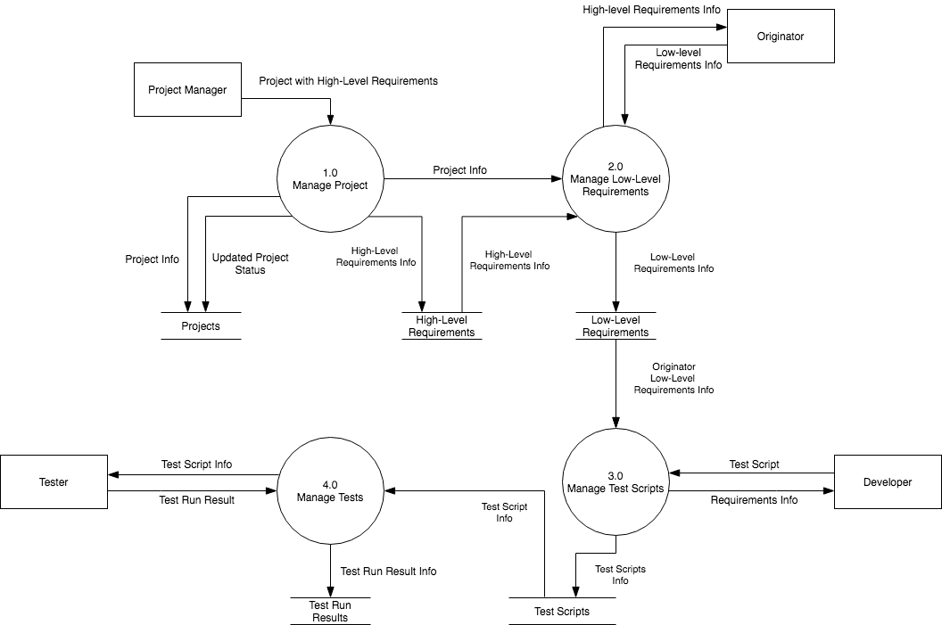

### **Level 2**

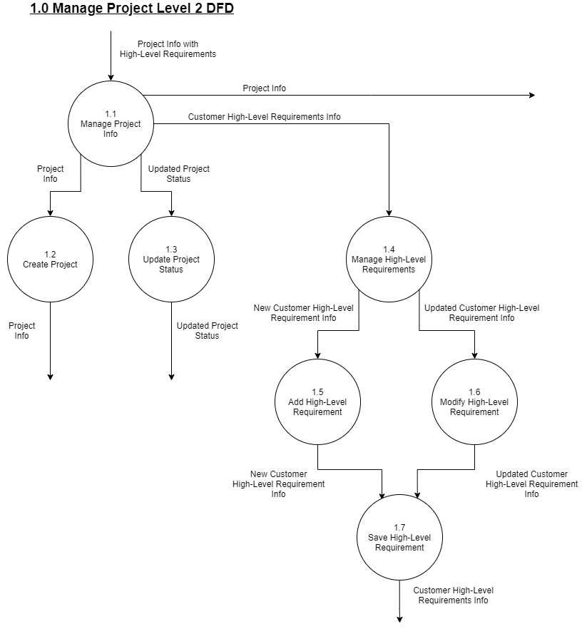

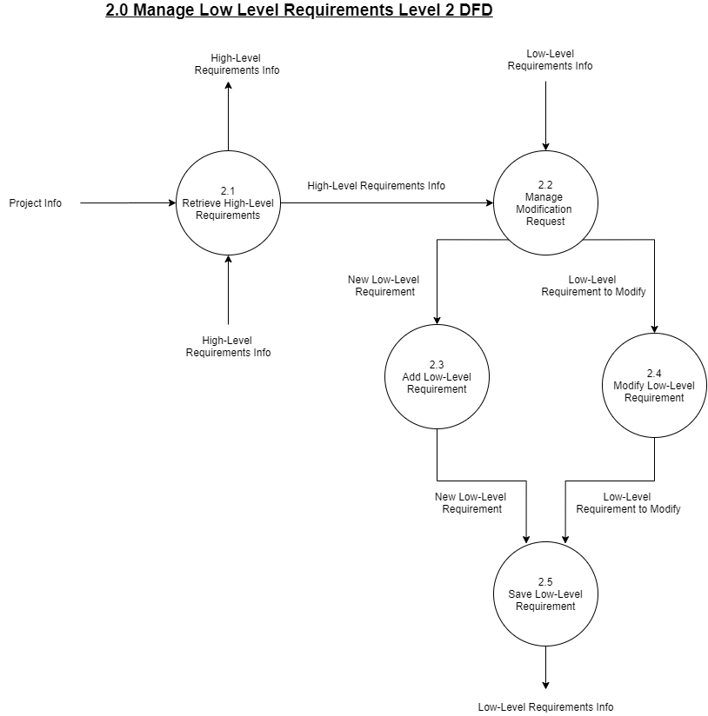

## 

## 

## 

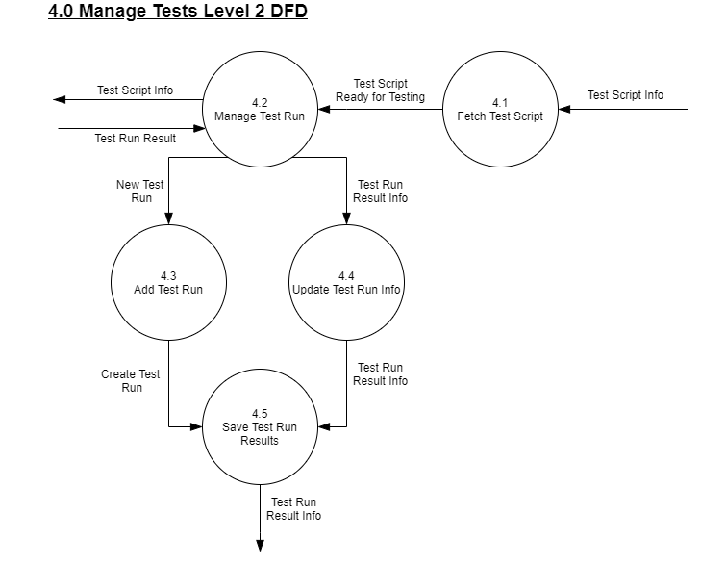

## 

## **Entity Relationship Diagram**

## 